**Session 7**

**Assignment 1**

**Part 1: Sales of different TV Task 4:**

Write a MapReduce program to modify Sales of different TV Task 2 to use a custom partitioner with 4 reducers. Make sure that all records whose company name starts with A-F (upper or lower case) should go to 1st reducer, those starting with G-L to 2nd reducer, those starting with M-R to 3rd reducer and others to 4th reducer.

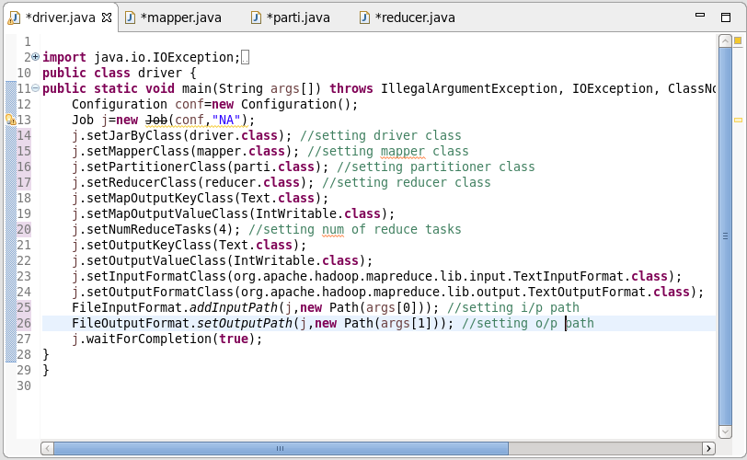

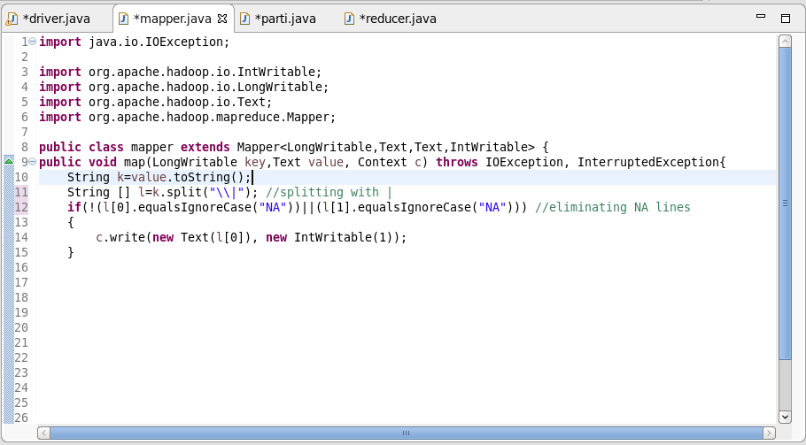

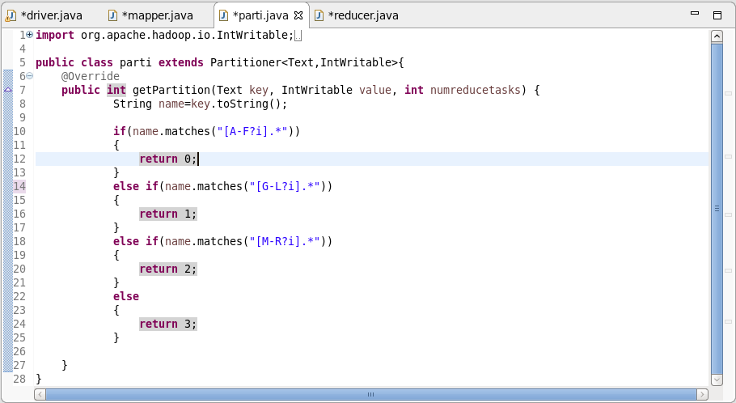

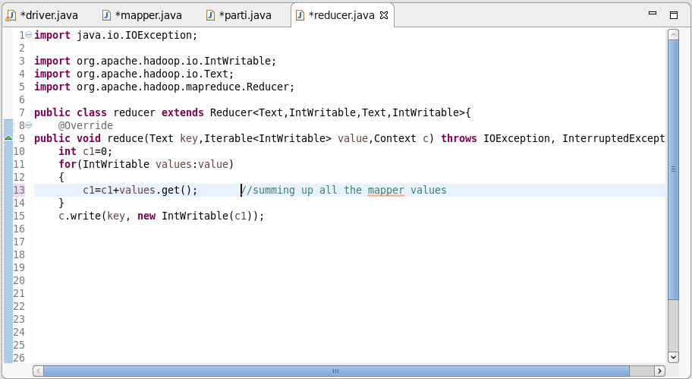

Outputs:

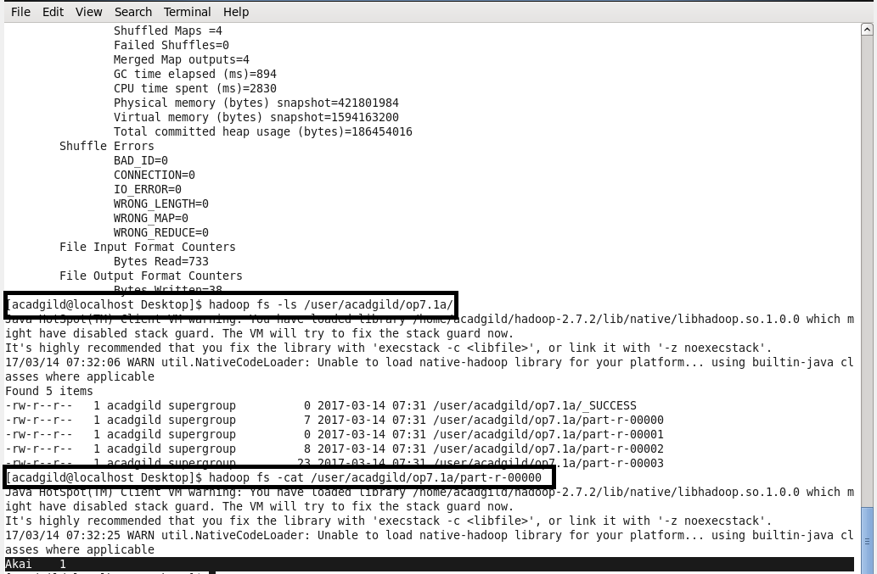

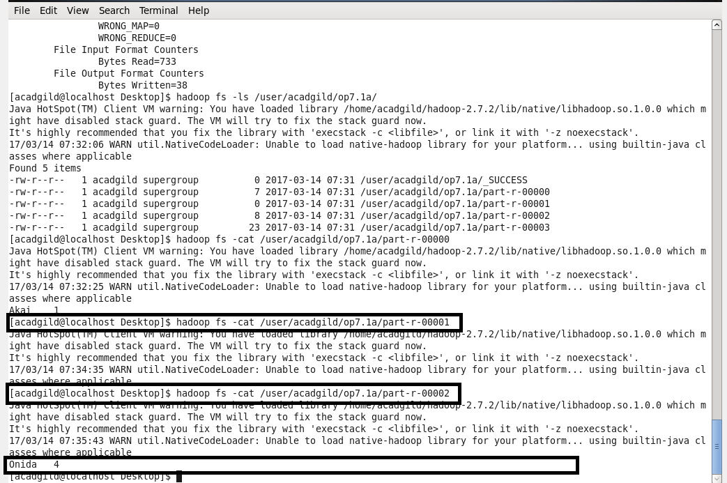

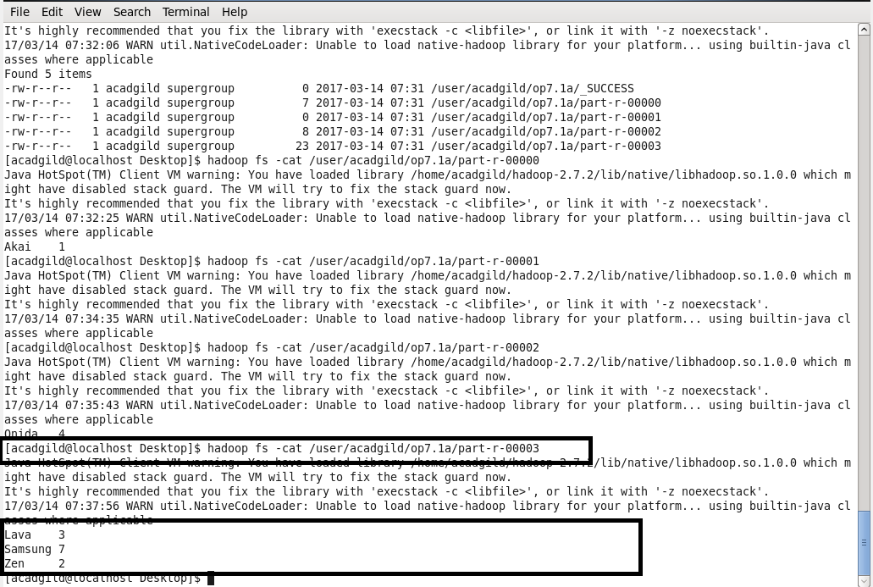

**Part 2: Sales of different TV Task 5:**

Modify Sales of different TV Task 2 to take advantage of Combiner.

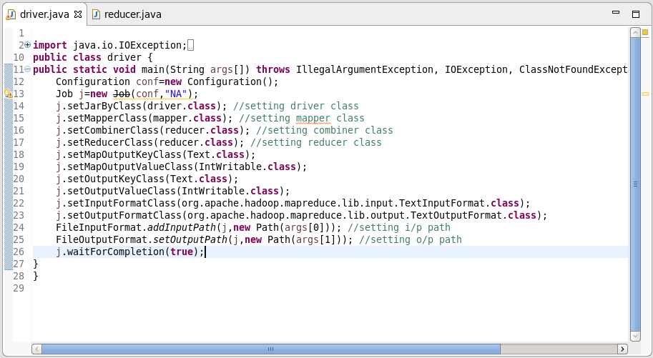

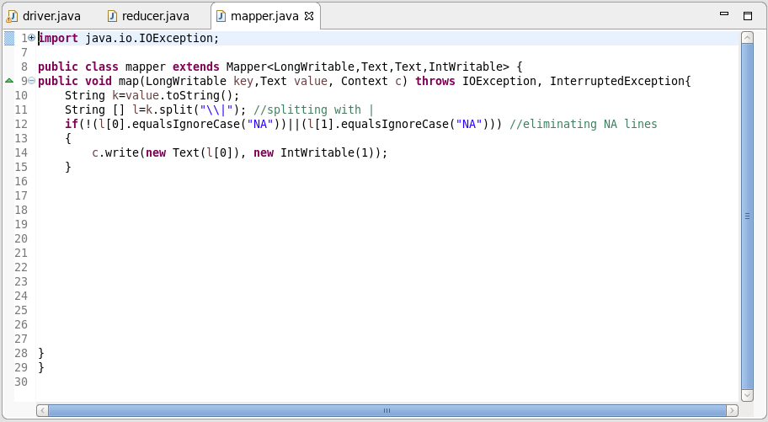

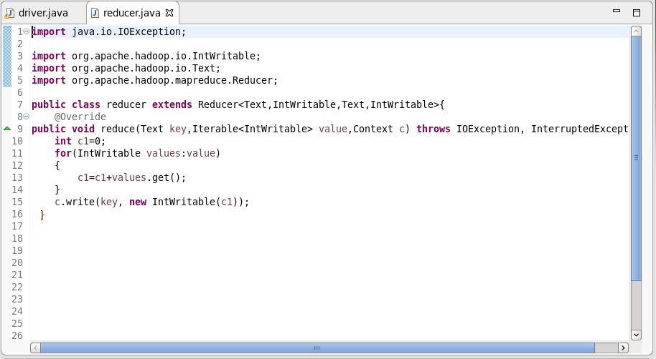

Output:

